**Summary**

The primary focus of the prototype was to address the issue of the spread of false information (also referred to as ‘fake news’) on social media by providing a platform for users to fact check and be alerted of potentially misleading articles. The initial plan was to create a web browser plug-in or a web application that allowed news consumers to only be notified of misleading content and/or flagged news articles. However, the initial plan required almost no user interaction, did not propose any solution to preventing the spread of false information, and set no standards for objective, high-quality journalism.

Upon research and user evaluations, the problem space and the domain remained far too ambiguous and large to be simply resolved via targeting social media platforms such as Facebook or Twitter. It was also far too unrealistic to force our system onto the consumers directly, when the problem exists within the content creators. To clarify, our research and evaluation suggest that users with preconceived biases are unlikely to shift their political views with a simple notification or an alert. In addition, users without preconceived biases will not be incentivized to fact check given the lack of standards for journalism. For example, current popular news and media outlets have no set standards for high quality journalism while users also lacking a template to compare their expectations with. From the results of our user evaluation and research, we suggest that average news consumers are almost forced to trust the subjectivity that have been moderated by the prestige and perceived high reputations of news outlets that have been established for generations (e.g., New York Times, BBC).

We, therefore, shifted our focus and proposed a new system that allowed trusted users to set new standards for objective, high quality journalism based on a performance rating rubric we have created. The 6 criteria (shown in *figure 2*) represent up the core qualities of objective journalism and aim to provide a new set of standards for modern journalism. It is hoped that as a result of this system and the rise in quality and objectivity of modern journalism, spread of false information and fake news will be made less relevant.

**Key Research Highlights**

1. **Journalism Objectivity should not be grasped as an absolute, but as performance** *(Boudana, S. 2011)*
   1. Creation of a rubric/system to measure journalism as performance
2. **Journalists** are no longer just an average worker. With their current power over the population, they should be **required to be transparent** as possible with their work. *(Meier, K. & Reimer, J. 2011)*
   1. One of the criteria in the rubric
3. Cross-Longitudinal study in Chilean politics -> **rise in more objective journalism after the use of objective and analytical reporting**. *(Mellado, 2015)*
   1. Example of one of the transformation in journalism due to objectivity focus writing
4. Bias is not removable, however if the author can justify whichever reality he/she is trying to portray with quality facts, information, and arguments, **bias can be ignored**. *(Broersma, 2010).*
   1. Solution or a work around with our bias issue, as long as there is justification (supported by evidence and facts), bias can be ignored.
5. A **system must help users** evaluate what they are seeing. *(Waldrop, 2017)*
   1. Shift in our focus: Priority on creating a system – platform doesn’t necessarily matter.
6. An objective **system** is operated and **maintained** by its **contributors**. *(Thorsen, 2008)*
   1. No system is perfect. To maintain and analyze a high volume of news articles (politics), our system must have faith in the contributors (power users) to provide an objective performance rating based on the system/rubric we have created.
7. **Objective** **journalism** is directly **correlated** to **high**-**quality** **journalism** (perceived quality increases as well as actual) in an Objectivity Experiment in Germany. *(Mothes, 2017)*
   1. Another reason why we switched our design focus to ‘fixing journalism’ from ‘outright remove fake news from consumers’.

**Process**

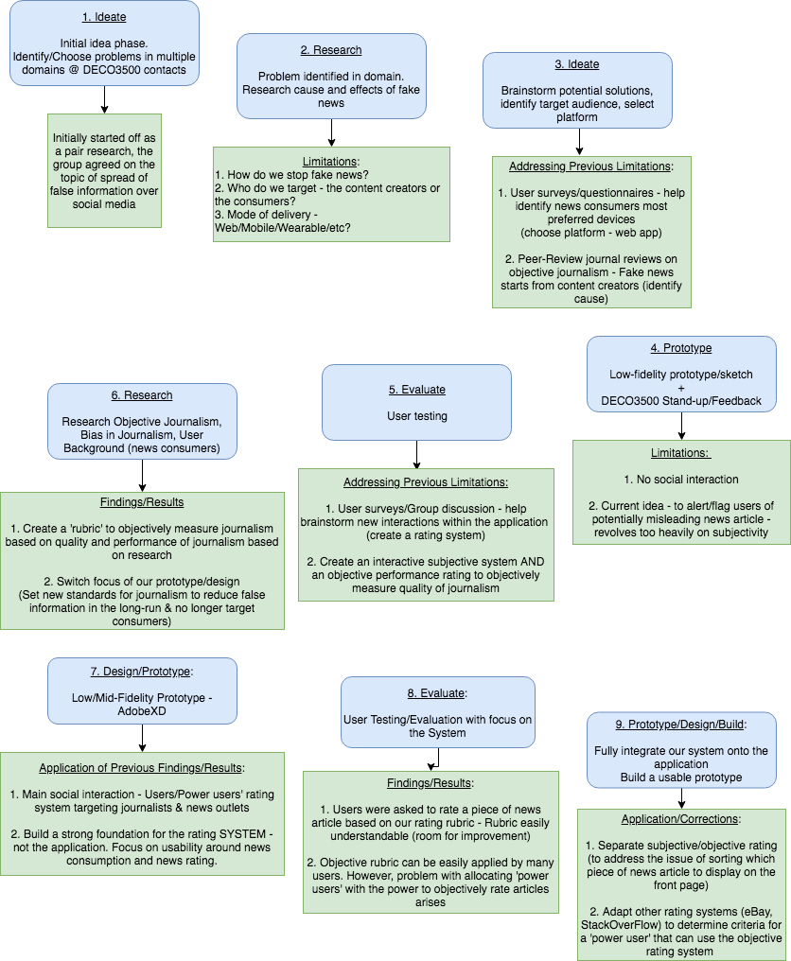

*Figure 1*

**Objective Journalism**

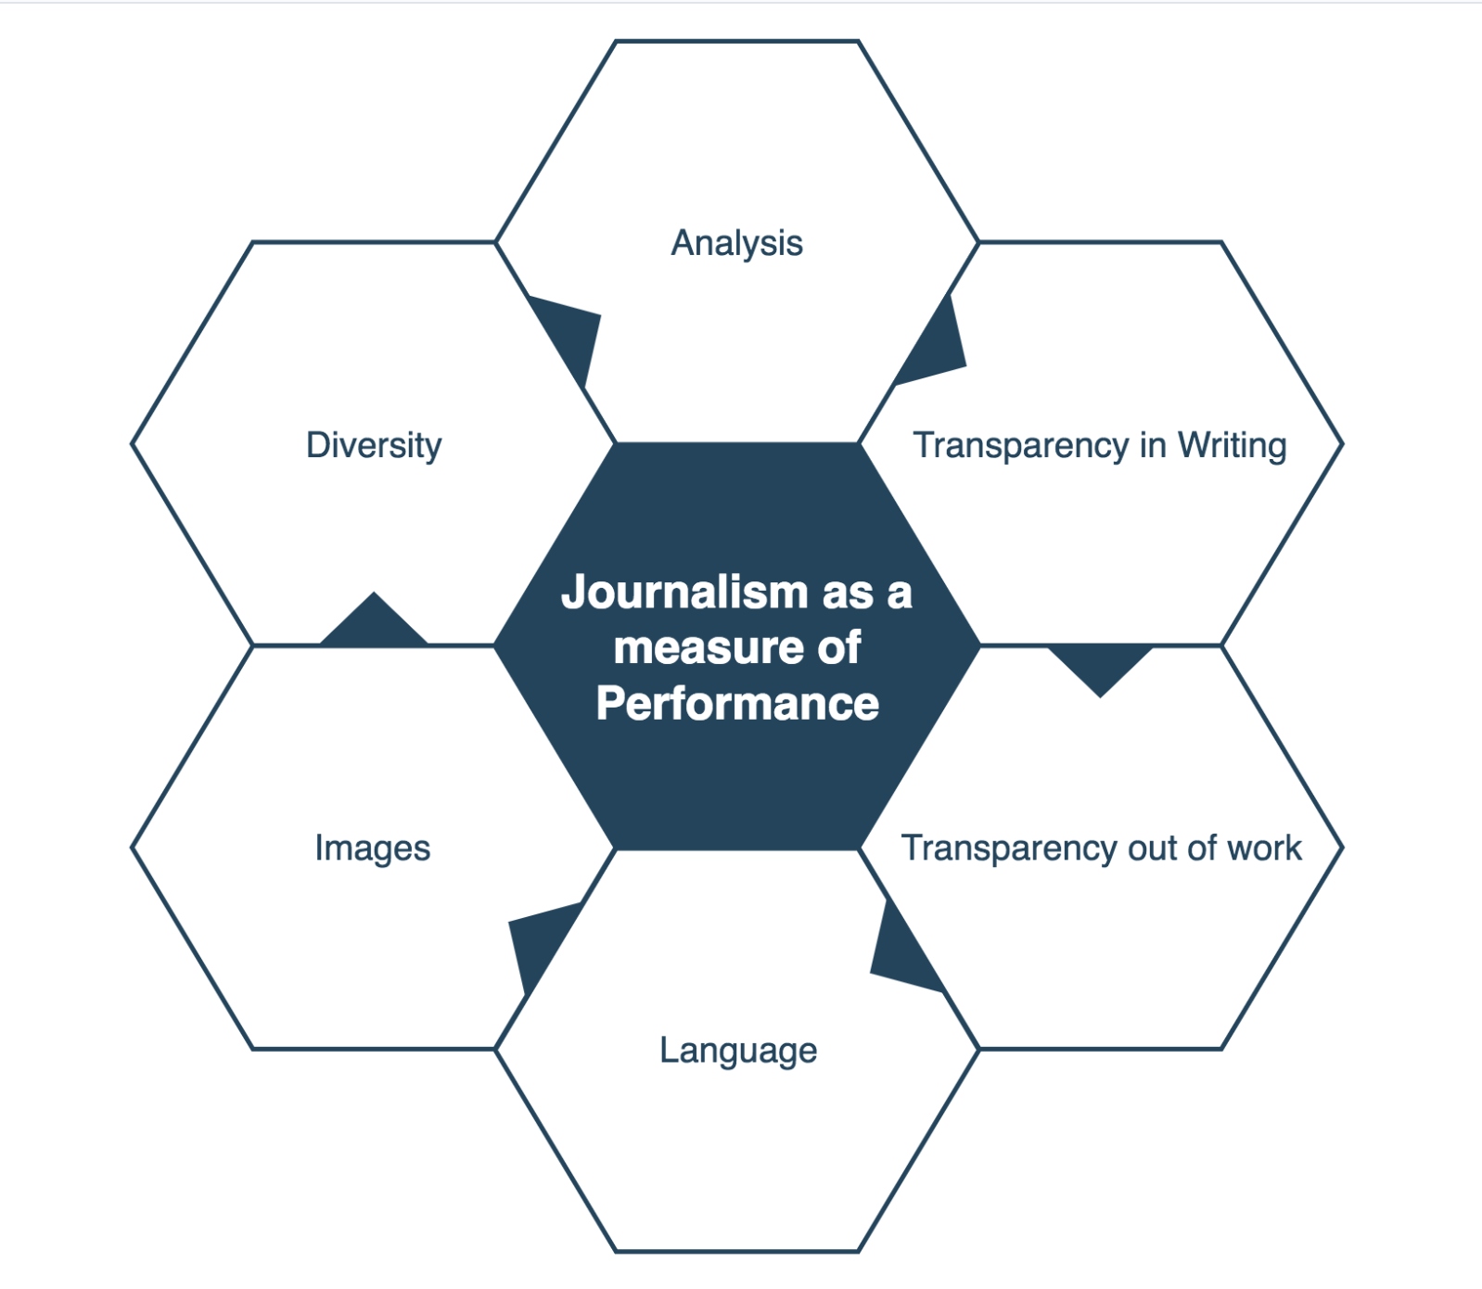

* Based on qualifications of objective journalism (Boudana, 2011; Broersma, 2010; Krause, 2011; Meier & Reimer, 2011; Mellado, 2010; Munoz-Torres, 2012; Post, 2015; Stenvall, 2008; Umeogu & Ojiakor, 2012; Ward, 2012; Westgate, 2013)

*Figure 2*

Future Directions:

Fully-Implemented:

* Strong foundation for a more objective, performance/quality-based rating system and/or rubric for modern journalism.
* Our current rating system is easily modifiable (with the inevitable shift in journalistic qualities and styles in the future – (*Esser & Umbricht, 201*4)).

Partially-Implemented:

* Our design currently lacks a strong system to differentiate power users (ability to use the objective scale) and regular users (separated, subjective rating system used to filter out unpopular news content – e.g., /r/politics, /r/worldnews).

To-Do:

* Transparency: All users should be able to (if they choose to do so) see the justification for a certain objective/performance rating. Create another system or a functionality that allows users to have access to the information.
* Unbiased/Objective method to differentiate power users & regular users. Research.

Roles:

|  |  |
| --- | --- |
| Member | Role |
| Justin | Primarily focused on research and writing. Research includes studies on objective journalism, bias in journalism, and standards for high-quality writing/journalism. Responsible for creating the objective/performance rating rubric for journalism. Promotional website. |
| Eddy | Github management, focused on user testing and evaluating. |
| Oscar | User testing, user test results analysis, promotional poster |
| Ian | Primarily focused on developing low and high fidelity prototyping including wireframes and website coding. |
| Collective | Everyone was involved in the design processes, user questionnaires (excluding evaluation), brainstorming, and documentation of work. |

Useful Links:

Conference Poster

Promotional Website

References (Peer-Reviewed Journals/Studies Only)

Boudana, S. (2011). A definition of journalistic objectivity as a performance*. Media, Culture & Society, 33(3*), 385-398.

Broersma, M. (2010). The unbearable limitations of journalism: On press critique and journalism's claim to truth. *International Communication Gazette, 72(1),* 21-33.

Esser, F., & Umbricht, A. (2014). The Evolution of Objective and Interpretative Journalism in the Western Press: Comparing Six News Systems since the 1960s. *Journalism & Mass Communication Quarterly, 91(2)*, 229-249.

Krause, M. (2011). Reporting and the transformations of the journalistic field: US news media, 1890-2000. *Media, Culture & Society, 33(1),* 89-104.

Meier, K. & Reimer, J. (2011). Transparenz im Journalismus. *Publizistik, 56(2),* 133 -155. (English Translation)

Mellado, C. & Humanes, M. (2015). The Use of Objective and Analytical Reporting as a Method of Professional Work: A Cross-Longitudinal Study of Chilean Political Coverage. *The International Journal of Press/Politics, 20(1),* 67-84.

Mothes, C. (2017). Biased Objectivity: An Experiment on Information Preferences of Journalists and Citizens. Journalism & Mass Communication Quarterly, 94(4), 1073-1095.

Muñoz-Torres, J. (2012). TRUTH AND OBJECTIVITY IN JOURNALISM. *Journalism Studies*, *13(4),* 566-582.

Post, S. (2015). Scientific objectivity in journalism? How journalists and academics define objectivity, assess its attainability, and rate its desirability. *Journalism, 16(6),* 730-749.

Rasul, A. (2014). Journalistic norms in multicultural societies: A critical evaluation of the social construction of realities through objective journalism. *Pakistan Vision, 15(2)*, 40-57.

Stenvall, Maija. (2008). On Emotions and the Journalistic Ideals of Factuality and Objectivity: Tools for Analysis*. Journal of Pragmatics: An Interdisciplinary Journal of Language Studies, 40(9*), 1569-1586.

Thorsen, Einar. (2008). Journalistic Objectivity Redefined? Wikinews and the Neutral Point of View. *New Media & Society, 10(6),* 935-954.

Umeogu, B. & Ojiakor, I. (2012). Sycophancy and Objective Journalism. *Advances in Applied Sociology, 2(3),* 159-166.

Waldrop, M. (2017). The genuine problem of fake news: Intentionally deceptive news has co-opted social media to go viral and influence millions. Science and technology can suggest why and how. But can they offer solutions? *Proceedings of the National Academy of Sciences of the United States, 114(48),* 12631.

Ward, S. (2012). The emotional commitment to objective journalism. *Media, 15(2),* 65 -66

Westgate, C. (2013). Notes on the wire: Ballads, biases, and borders of performance journalism. *Media, Culture & Society, 35(8),* 996-1010.